How Data is represented by Computer Systems
Before natural language data can be written to a computer recording device like disk, tape or memory it needs to be put in a format that the computer recognizes. For example, to record data blocks on the surface of the disk the data needs to be represented as a string of pulses, where each pulse is in either one of two states: positive or negative polarity. Since there can be only two states, we refer to this as binary notation. The direction of the polarity (i.e. + or -) determines if the data is interpreted as a binary one or a binary zero.

So how do we tell the computer to store the letter “A”, specifically a capital A? Well, in order to represent a human readable character in other than a one or zero, computer designers came up with various coding schemes consisting of a string of ones and zeros to represent many of the common characters needed by computer users. There are three very popular coding schemes in use today: ASCII, EBCDIC and Unicode. These coding schemes made it practical for us to record and process natural language characters on “two-state” or binary computing devices. Let’s take a look at how the character “A” is encoded in ASCII.

Below is a small sample of an ASCII and EDBDIC conversion table (full conversion table can be found at http://www.natural-innovations.com/computing/asciiebcdic.html) that we’ll use to convert our “A” into a binary string of ones and zeros, suitable for recording in primary or secondary storage (i.e. in memory or on a disk’s surface.)

ASCII EBCDIC ASCII EBCDIC ASCII EBCDIC
A 41 C1 a 61 81 0 30 F0
B 42 C2 b 62 82 1 31 F1
C 43 C3 c 63 83 2 32 F2
An ASCII capital “A” is a Hex “41” and Hex “C1” in EBCDIC
D 44 C4 d 64 84 3 33 F3
E 45 C5 e 65 85 4 34 F4
F 46 C6 f 66 86 5 35 F5
G 47 C7 g 67 87 6 36 F6
H 48 C8 h 68 88 7 37 F7
I 49 C9 i 69 89 8 38 F8
J 4A D1 j 6A 91 9 39 F9
K 4B D2 k 6B 92
L 4C D3 l 6C 93 space 20 40
M 4D D4 m 6D 94
N 4E D5 n 6E 95
O 4F D6 o 6F 96
P 50 D7 p 70 97
Q 51 D8 q 71 98
R 52 D9 r 72 99
S 53 E2 s 73 A2
T 54 E3 t 74 A3
U 55 E4 u 75 A4
V 56 E5 v 76 A5
W 57 E6 w 77 A6
X 58 E7 x 78 A7
Y 59 E8 y 79 A8
Z 5A E9 z 7A A9

ASCII to EBCDIC Conversion Table
Using the above ASCII conversion chart we see that a capital “A” is a hexadecimal 41. If we convert this hexadecimal number to its 8-bit binary representation we get “01000001”. We use hexadecimal as a “shorthand” method so that we don’t have to remember or write down the binary values; since binary numbers can get quite long and tedious to work with. Remember from the class lecture that the hex 4 is 0100 in binary and the hex 1 is 0001 in binary. So the disk surface will have the polarity changed to record the following string of 8 bits: 01000001. Let’s look at this again. This time let’s also convert a lowercase “a” as well:

Natural: A a

Hex: 41 61

Binary: 0100 0001 0110 0001
With this method for converting natural language characters to binary you can represent any character to a binary equivalent and make it easy store on digital media.

Let’s try another Example
Let’s take the name “Dave D” to see how it is stored on the disk:
Natural: D a v e D
Hex: 44 61 76 65 20 44
Binary: 0100 0100 0110 0001 0111 0110 0110 0101 0010 0000 0100 0100

This is what “Dave D” looks like written to disk or stored in main memory
What are the most Common Coding Schemes?
Here are the three most common computer coding schemes. All three of them are still in use today. Can you think of any issues with trying to distribute data in a distributed computing environment going from one coding scheme to another?
ASCII - The American Standard Code for Information Interchange started out as a standard seven-bit code that was proposed by ANSI in 1963 and finalized in 1968. Much of the work on ASCII has been credited to Robert W. Bemer. ASCII was established to achieve compatibility between various types of data processing equipment. Later-day standards that document ASCII include ISO-14962-1997 and ANSI-X3.4-1986(R1997).
ASCII, pronounced "ask-key", is the common code for smaller computing platforms. The initial ASCII character set consisted of 128 characters that include decimal numbers, letters, numbers, punctuation marks, and the most common special characters. The Extended ASCII character set consists of the original 128 characters plus an additional set of characters making it a 256 character coding scheme.
EBCDIC - Extended Binary Coded Decimal Interchange Code was a further development of older codes like BCDIC, BCD dating back to work done by Herman Hollerith. EBCDIC was designed as an 8-bit code, because the new System 360 used a 32-bit machine word. With 8 bits, EBCDIC supports 256 characters. It is used primarily in the larger computer environments, specifically mainframes and some mid-frame computing platforms.
EBCDIC, pronounced “ebb-c-dick”, was deployed in the early 1960s by IBM when they announced a new computer series that became known as System 360. It turned out that EBCDIC followed a direction totally different from ASCII, where the heritage of paper tape was clearly established. So EBCDIC and ASCII are not compatible and require a translation to move data from an EBCDIC machine to an ASCII machine and vice versa.
Unicode – Universal Code has a 16-bit coding scheme that compensates for the short-comings of 7 and 8 bit coding schemes. ASCII and EBCDIC worked fine for English and the Romance languages but didn’t have enough character combinations to support the alphabets of languages from Eastern Europe, Asia and Africa. With 16 bits Unicode can support over 65,000 characters. The first 256 Unicode characters are the same as ASCII.
Two Important Management Issues to Remember
There are two very important principles to remember when moving data in a heterogeneous computing environment. Data moved from one computer to another may be using different coding schemes i.e. ASCII to EBCIDIC or vise versa.
1. This data movement will require a conversion to the coding scheme on the target platform. For small data sets this may not be an issue; but for very large data sets found on most enterprises this data conversion will be noticeable overhead that affects performance.
2. Notice that the collating (sort) sequence is different between ASCII and EBCIDIC. Numeric and lower case characters sort in different sequences in each. For example in ASCII numbers sort before letters but in EBCDIC letters sort before numbers.

Distributed Computing Model
Last time we discussed Alex Berson’s distributed computing model where he described that an application program can be distributed as layers across a network. Berson concluded that an application can have three fundamental layers and each layer can inter-operate on separate computing devices in a heterogeneous computing environment; thereby, creating the illusion (user experience) that the application is running on a single computing platform. He summarized these layers as follows:
- Presentation Layer – This is the user interface, which is the part of the application that allows the user to interact with the application. This can include web pages, screens where inputs are collected and outputs are displayed.
- Business Logic Layer – This is where data is manipulated and where calculations take place. This is the place where inputs are processed and outputs are created.
- Data Management Layer – This is where the data (at rest) resides. Data management includes the facilities for organizing, cataloging, storing, securing, providing access and protecting/recovering data assets.
Lab Exercise Set Up
In this lab you will explore an enterprise Integrated Development Environment (IDE), Rational Developer for System z (RDz) to learn the following.
Learning Outcomes
The student will be able to:
- Describe data formats to show how data is represented by computer systems
- Explain how human recognizable data is stored and manipulated by a computer
- Describe the importance of data encoding schemes: ASCII, EBCDIC, Unicode
- Explain the relationship among hexadecimal, decimal and binary number systems and its relationship to computers
- Describe the general uses of an IDE, RDz and Interactive Systems Programming Facility (ISPF)
- Describe the multi-tier architecture

Additional Resources
The following web sites contain useful information about RDz:
- Rational Developer for System z, http://www-306.ibm.com/software/awdtools/rdz/
RDz software download is available from this site
- Developer Works, https://www.ibm.com/developerworks/mydeveloperworks/groups/service/html/communityview?communityUuid=df67969e-ba40-44c7-a1ca-ef4a2aa99e01
- Eclipse Open Source Community, http://www.eclipse.org/

Lab Exercise
In this lab you will explore the capabilities of RDz. Rational is a software division of IBM. As you are working through the steps in this lab be mindful of the questions posed at the end of this lab exercise.

- To launch RDz (if the light blue octagon is not on the desktop) open Rational Developer for System z by selecting it from Start menu → All Programs → IBM Software Development Platform → IBM Rational Developer for System z → IBM Rational Developer for System z.

- After you have established a connection, you should see your new connection in the Remote Systems Explorer. If you called it GET239, right click on the GET239 and select Connect. You should see a logon dialog box like this. Enter your z/OS User ID and your password according to the instructions below:
- Use the SUSnnn User ID that you were assigned in class

- If you have completed the previous lab you can skip this step. Use password created from Lab 1.

- Then click OK
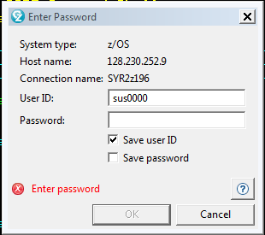

- Once you logon from your Remote Systems Explorer you will see files (datasets) in your account. They should like similar to this:
Expand the SHARE file folders by clicking on the + sign. You will find a dataset called “SHARE.GET239.CNTL” click on the + sign to find the LAB2DATA file then double click on it.

The file, “LAB2DATA”, will be moved from the enterprise server to the desktop machine and converted from EBCDIC to ASCII.

Since RDz knows that this was originally an EBCDIC file it remembers it and displays it to you as well.

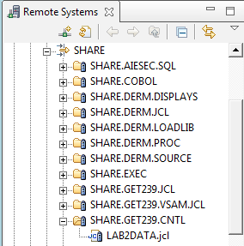

If you do not see the SHARE folder, you can create a “filter” that will allow you to access it like you see above. To create a filter, right click on MVS Files, select New Filter and you will see this dialog box:

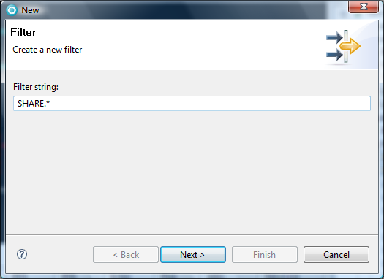
Type SHARE.*, click Next, name your filter SHARE, then click Finish

- The file that you opened is a list of student data that will look similar to this. It should be in character format so that it is in a “human readable” format. Keep in mind that the data is actually being viewed on a small ASCII or Unicode machine.

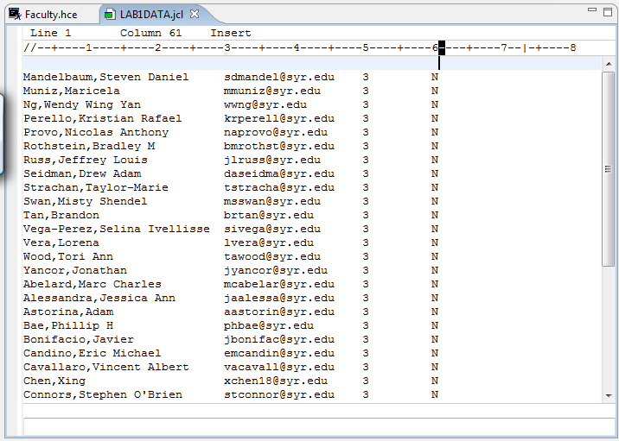
Notice the data is in “human readable” form.

Let’s see what it looks like in Unicode, ASCII and EBCDIC

- With your cursor in the data, right click then select → Source → Hex edit Line

Here you will see the highlighted line represented in all three major coding schemes.

If you click in this box on the characters in the first line the associated code will be highlighted
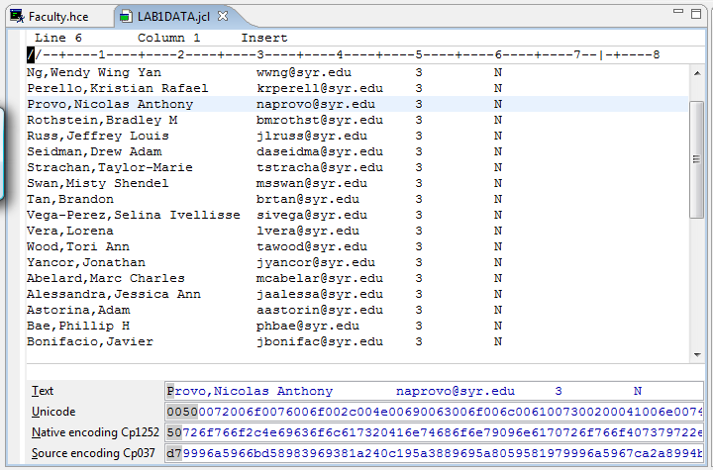

Notice the RDz editor displays the text in natual language first then all 3 major coding schemes: Unicode (16 bit), ASCII then EBCDIC.

To prove that the data is stored on the Mainframe in EBCDIC we need to look at it in an editor in hexidecimal as well. So let’s logon directly to the mainframe by using the z/OS Operating System’s Menu interface, ISPF. ISPF stands for Interactive Systems Programming Facility. ISPF has an editor we can use to prove that the data is stored in EBCDIC.

To Access ISPF from RDz, right click on the Remote Systems z/OS connection (you may have called it GET239) that you established above then select Host Connection Emulator Support.

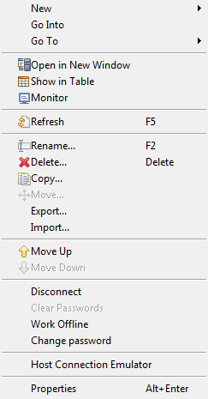
Clicking on this option will launch ISPF, the menu-based Interactive Systems Programming Facility. It will open up in the middle of your screen.

Keep in mind that you scale the size of these views.

- In this dialog box in the middle of your screen verify that you have the correct Host Connection Properties to connect to the mainframe. Here we need to change the port number and everything else looks good. Save these settings then press connect.
Verify then save these parameters then click Connect

1. Session type: 3270 for the input device type

2. Host Port: change to 623

3. Screen size: 24x80, 24 lines down by 80 characters across

4. IP Address: 128.230.252.9

5. Code page: Accept the default
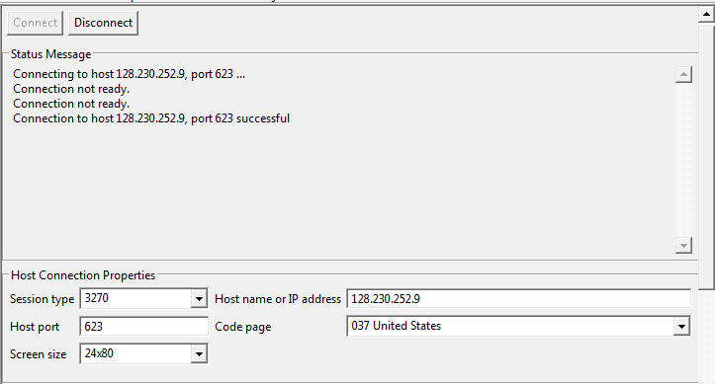

- You should see the z/OS Welcome screen. Here you will provide your logon credentials that were assigned in class. At the cursor below enter L then a space followed by your User ID then press enter.
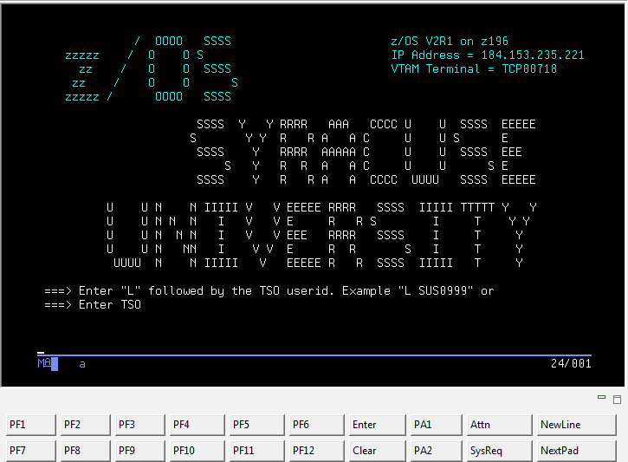

- z/OS will validate your User ID and return this screen. Enter your password then press enter.

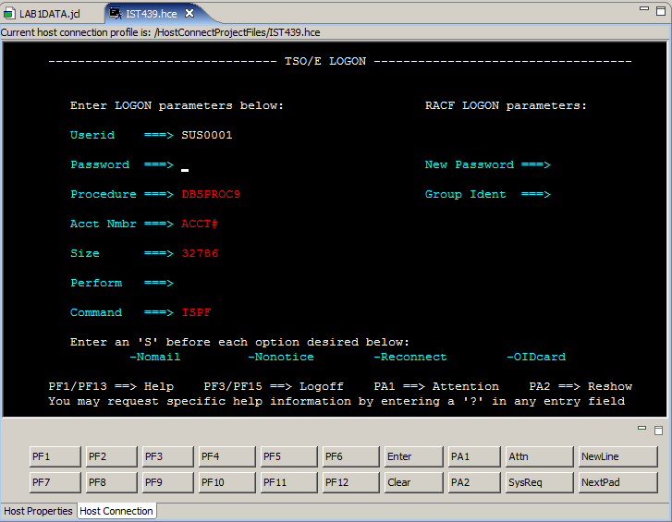

- Once your logon credentials have been verified you will receive the following messages. The *** means to press enter. So press enter and you will see the Primary Options Menu.
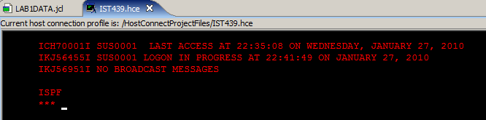

- Here is the Primary Options Menu. You can perform all systems administration or systems development tasks through this facility. It is menu driven so the options on this screen take you to sub-menus where there are more choices.
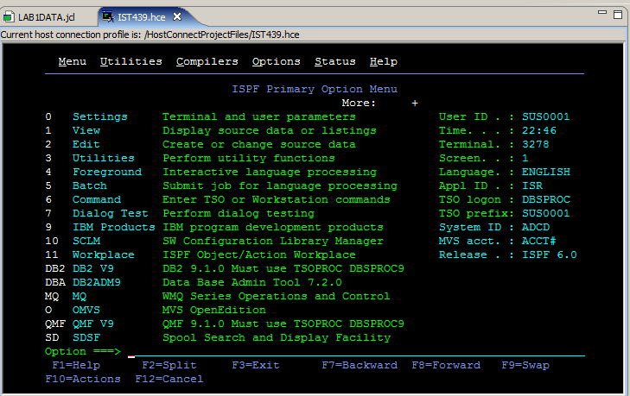

- From Primary Option Menu command line at the bottom of the screen identified by the “Option=➔” enter 3.4 then press enter. You will see a screen that looks like this. At the Dsname Level . . . type SHARE to get access to the files in this folder. Then press enter.
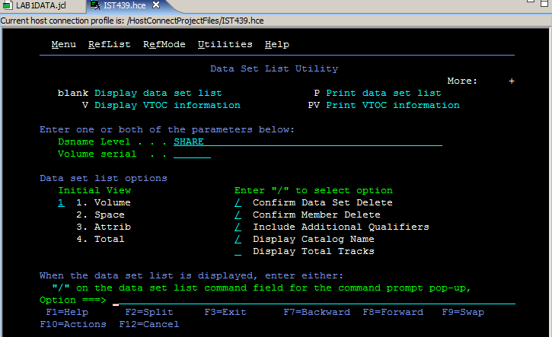

- ISPF returns a list of all of the files and file folders that start with the high-level qualifier “SHARE” These are actually file folders. We still have to open up the SHARE.GET239.CNTL folder to get our LAB2DATA file so that we can see the data in Hex. On the line to the left of the SHARE.GET239.CNTL place a V for view, then press enter.

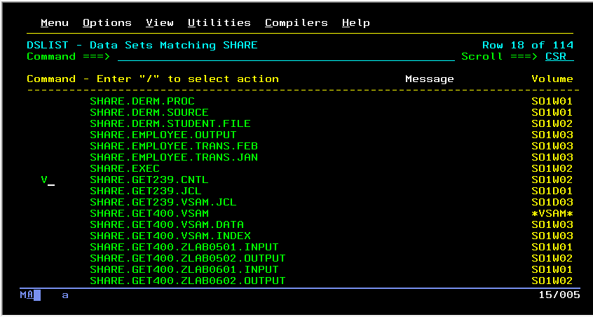

- You should see all of the files in the SHARE.GET239.CNTL folder. In this case there should be only one. On the line to the left of the LAB2DATA file place an S for select, then press enter.

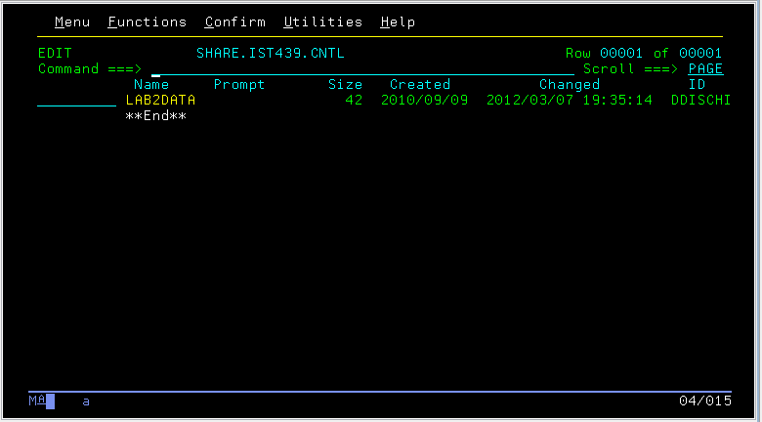

- ISPF will open up the file editor for you to see and modify the data in the LAB2DATA file. We don’t what to change the data. We just want to see it in EBCDIC. To view the data in Hex, tab to the command line, Command =➔ at the bottom of the screen and type HEX ON.

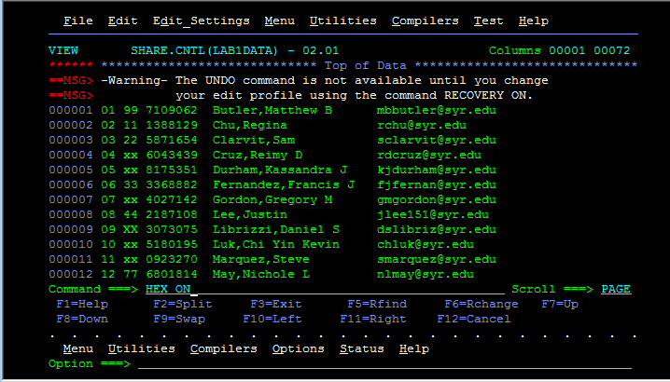

- Here is the Hex representation of the the data. See if you can identify the EBCDIC codes in Hex. Hex is much easier to read and use less screen real estate than binary.

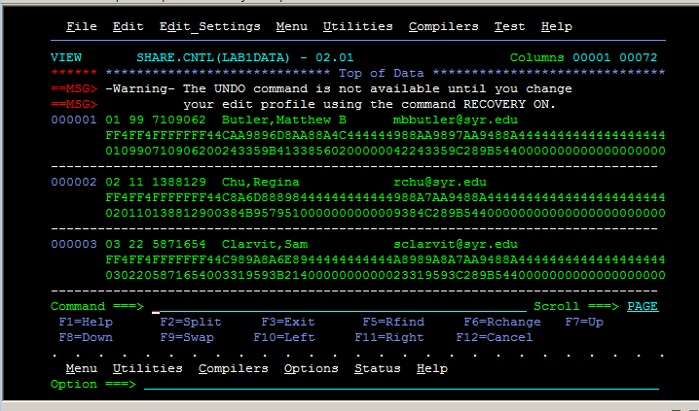

Type the answers to the following questions and print the RDz and ISPF editor screens from the lab exercise showing the LAB2DATA ASCII and EDCDIC values. (20 points)

- Describe 3 major data coding schemes and where they are generally found.(6)
a.___________________________________________________________
_____________________________________________________________
_____________________________________________________________
_____________________________________________________________
b. ___________________________________________________________
_____________________________________________________________
_____________________________________________________________
_____________________________________________________________
c. ___________________________________________________________
_____________________________________________________________
_____________________________________________________________
_____________________________________________________________

- Convert the following five characters: Z, d, space, 9, ! to ASCII then list them in ascending collating (sort) sequence. (2)
_____________________________________________________________

- Convert following five characters: T, j, space, 2, + to EBCDIC then list them in descending collating (sort) sequence. (2)
_____________________________________________________________
- How does the computer determine the collating sequence (ie, sort order) of the ASCII or EBCDIC characters? (2)
_____________________________________________________________
_____________________________________________________________
- Discuss two management issues when transferring files from one computing platform to another that have different coding schemes. (4)
a. ___________________________________________________________
_____________________________________________________________
_____________________________________________________________
b. ____________________________________________________________
______________________________________________________________
_____________________________________________________________

- In this lab you used two computers that are connected to the same network. a. Using Alex Berson’s multi-tier architecture discussed in class; which layer did each computer perform in this architecture? b. What evidence do you have to support your thinking? (4)
a. ___________________________________________________________
_____________________________________________________________
_____________________________________________________________
_____________________________________________________________
_____________________________________________________________

b. ____________________________________________________________
______________________________________________________________
_____________________________________________________________
_____________________________________________________________
_____________________________________________________________

